Practice 7
Using the Spell Check

When you create a document in Word, you can use the electronic dictionary to check your spelling. The dictionary will find most words that are not correct in English. Then it will make some suggestions about how you can change the words. You choose the best correction.

Sometimes you will also need to ask a friend or look in a regular dictionary to find the correct spelling.

Watch your teacher’s demonstration. Read all the instructions before you begin.

Instructions:
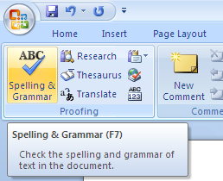
- Click on Review to find the dictionary on the top left side of the window.

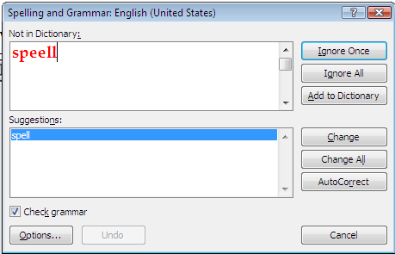
- You will see a Spelling Dialog box. Study the example here. Click Change when you agree with the suggestion. Click ignore if you think that is best.

3. Look at the list of misspelled words on the next page.

Name:
Date:

Lesson 7

Here are the misspelled words:

Pincil, floppiy disk, screenn, monnitur, compyutor, eddited, dictionery,

- Your spellchecker will show mistakes in the list.

- You will see suggestions for how to spell words correctly.
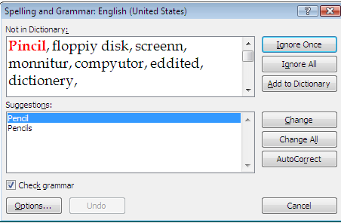
- Sometimes you will see more than one choice. Think about which one is best. Sometimes the first suggestion is best. Sometimes the second or third choice is best. Highlight the best choice.

- Click on the Change button when you see the correct choice.

- Do not click on the Ignore or Add buttons.

- You can use Ignore at another time. It will help you with words that are not English, like your name, or a classmate’s name.
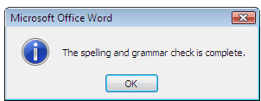
- When you finish you will see a message box like this. Click on OK.

Print page two and hand it in.

